ITEMS NOT ACCEPTED FOR CONSIGNMENT
In an effort to provide you with quality items and continue to grow our Auction House we have compiled a list of items that we WILL NOT ACCEPT at Oronoco Online auctions as of January 1, 2026. Exceptions or additions may be made by Auction House staff.
Untested electronics- need to be in working order or disclosed
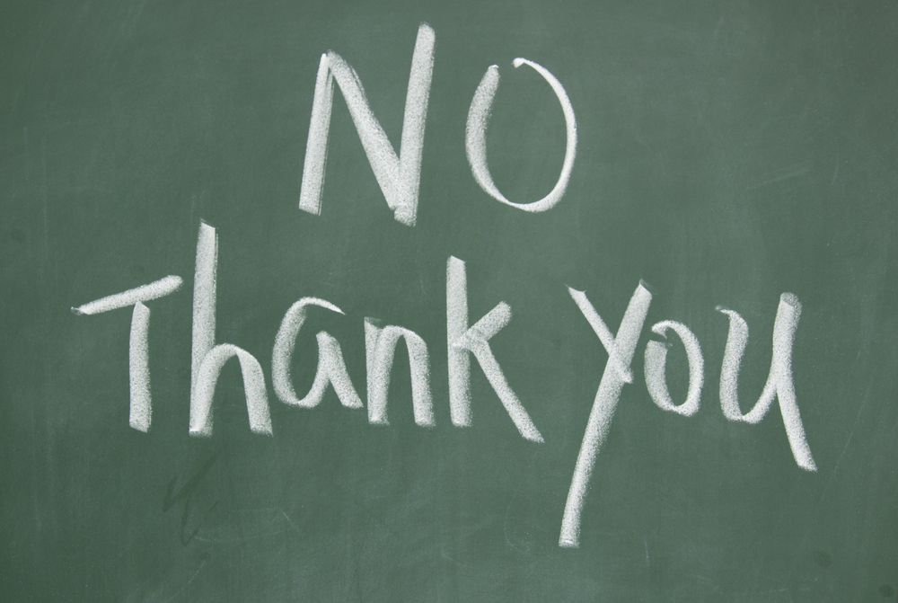
www.oronocoauctions.com
Contact Us
Oronoco Online Auctions
815 5th St NW
Oronoco, MN 55960
507-367-4500
info.oronocoauctions@gmail.com
www.oronocoauctions.com
Assorted photo frames
Figurines/ Precious Moments, Cherished teddies, angels, animals etc.
Televisions/Computers/Printers (We do take flat screens)
Infant items (including car seats, cribs, bassinets, strollers, stuffed animals)
Childrens Toys (Vintage accepted) – NO DOLLS/stuffies
Clothing (exceptions for Harley Davidson, hunting, furs, etc.)
USED small appliances, toasters, blenders etc. and worn Kitchen items
Non-Working large Major appliances/microwaves
Lamps (at discretion of Auction house)
Personal Care and Bath items, towels or linens (New only)

Recycle ONLY chemicals and paints (refridgerants/paints)
Milk glass and/or crystal serving pieces
Incomplete (less than service for 6) China or other serving sets
Incomplete/ misc glassware and/or shotglasses
Used/Expired Safety Equipment and/or accessories
Large Excersize equipment/weight benches
Broken or “last leg” Furniture/Single dining room chairs
School desks - Metal Desks –Office desks (roll tops and antiques only)
Overly dirty or moldy items/ misc items or items that cannot be identified
Items containing alcohol or tobacco
Live plants
**Holiday/Seasonal décor will be limited and accepted at the discretion of the Auction Staff during the months of September and October ONLY**

