ITEMS NOT ACCEPTED FOR CONSIGNMENT
In an effort to provide you with quality items and continue to grow our Auction House we have compiled a list of items that we WILL NOT ACCEPT at Oronoco Online auctions as of January 1, 2022. Exceptions or additions may be made by Auction House staff.
Books, cookbooks and magazines
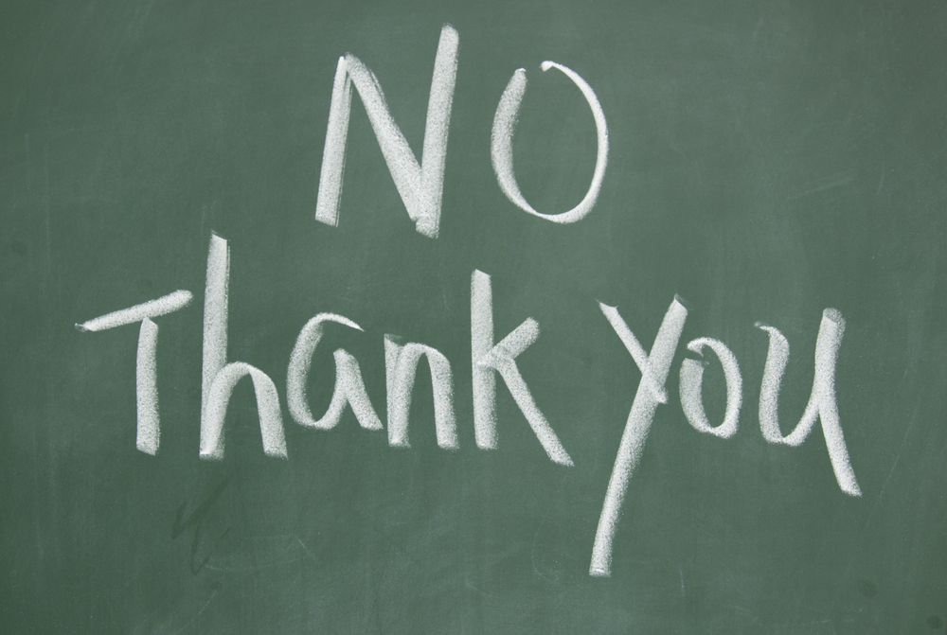
www.oronocoauctions.com
Contact Us
Oronoco Online Auctions
815 5th St NW
Oronoco, MN 55960
507-367-4500
info.oronocoauctions@gmail.com
www.oronocoauctions.com
Figurines/ Precious Moments, Cherished teddies, angels, animals etc.
VHS tapes, VHS players and cassette tapes/Cassette car stereos
Televisions and Computers (We do take flat screens)
Infant items (including car seats, cribs, bassinets, strollers etc)
Childrens Toys (Vintage accepted) – NO DOLLS
Clothing (exceptions for Harley Davidson, hunting, furs, etc.)
USED small appliances, toasters, blenders etc.
Non-Working large Major appliances
Lamps (at discretion of Auction house)
Personal Care and Bath items, towels or linens

Recycle ONLY chemicals and paints (refridgerants/paints)
Milk glass and/or crystal serving pieces
Incomplete (less than service for 6) China or other serving sets
Incomplete/ misc glassware and/or shotglasses
Tablecloths, linens, doilies
Large Excersize equipment/weight benches
Broken or “last leg” Furniture
Single dining room chairs
School desks - Metal Desks –Office desks (roll tops and antiques only)
Overly dirty or moldy items
Boxes or containers filled with Misc items or items that can not be identified
**Holiday/Seasonal décor will be limited and accepted at the discretion of the Auction Staff during the months of September and October ONLY**

